(Approx. 772 words)

Musings of an Apple Tyro
By Lorrin R. Garson, Potomac Area Technology and Computer Society, VA
January 2016 issue, PATACS Posts
www.patacs.org
newslettercolumnist (at) patacs.org

Microsoft Ends Unlimited Free Storage on OneDrive:
Microsoft announced on November 2nd (2015) that it would no longer provide unlimited OneDrive storage to Office 365 home subscribers and that it was slashing the amount of free OneDrive storage it provides by two-thirds. The reason given by Microsoft for this action is that a small number of users abused the offer by storing up to 75 TB of data. The amount of free storage in now 5 GB, down from 15 GB. Office 365 customers will have 1 TB of free storage. For more information see http://bit.ly/1kTb2FI. Also see http://bit.ly/1PGkqbu.

Erasing Data on SSDs:
Solid-state disk drives (SSDs or flash storage) offer enormous improvement over hard drives (HDD), particularly in performance, but SSDs are not without drawbacks. One of those drawbacks is, in practice, you cannot securely erase data (files and folders). With traditional disk drives, secure erasure is accomplished by repeatedly over-writing that area on the drive where the erased information was stored with a new pattern of bits. This cannot be done on SSDs because repeatedly writing to the same areas on an SSD will lead to premature failure of the storage device. SSDs deteriorate by repeated writing; they have a finite number of write cycles.

Controllers for SSDs spread writing around and minimize over-writing previously used loci, a process called “wear leveling”. Eventually deleted data on SSDs gets over-written but there is no way to predict when and fragments of data may persist for a very long time.

So how do you deal with this problem? Probably the most practical way is to create and store sensitive information in an encrypted environment such as an encrypted dmg file on a Mac (created with Disk Utility) or using VeraCrypt on Macs, PCs or Linux machines. Of course an SSD or HDD drive can be rendered unreadable by drilling holes in the media or smashing it with repeated blows with a hammer. Incineration works too.

By the way, defragmentation is useless on an SSD and such action decreases the lifespan of the device. The “Secure Empty Trash” function has been eliminated from the most recent version of OS X for Macs (OS X El Capitan) probably because most buyers are opting for SSDs rather than HDDs. See http://bit.ly/1WRaQrY for details on how SSDs work.

Finally, you should ask yourself the question “How secure do I really need to make my computer?” Most of us are not dealing with State secrets on our home computers. The explanation given above should provide adequate protection for medical, financial and other sensitive information. Keep in mind (1) there is much more to security than protecting data on our storage devices and (2) there is no such thing as absolute security. See the following for sage advice.

- See http://bit.ly/1RUjMpV for “10 Important Computer Security Practices You Should Follow”.
- See http://zd.net/1O7u4SE for “10 [more] Security Best Practice Guidelines for Consumers”.
- And from the U.S. Department of Homeland Security (US-Cert) see http://1.usa.gov/1kTcV5k.

Malwarebytes for Macs:
Many (most?) users of Apple computers do not use anti-virus/malware software. However, in October (2015) I installed Malwarebytes for Mac. This free application is designed to detect and remove malware, adware and potentially other unwanted programs. Malwarebytes has been available for PCs for many years and is widely used. Malwarebytes for Mac can be downloaded from http://bit.ly/1Ps31oh. The application (Figure 1) is straightforward to use and on my iMac executes in about four seconds (7 seconds on a MacBook Pro) and so far has only returned the message “Malwarebytes did not find any malware or adware on your system”.

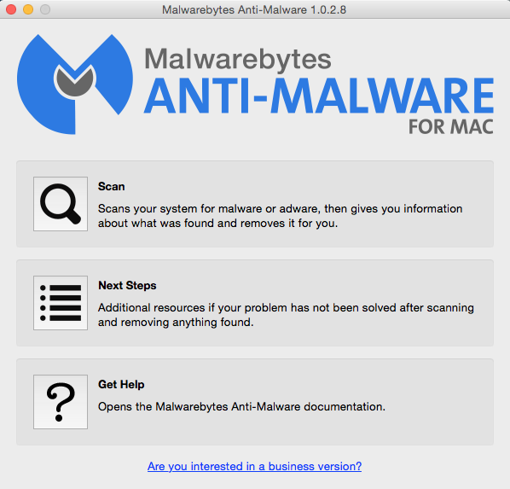
Figure 1

It appears that attacks and penetrations of Apple computers and other Apple devices are becoming more prevalent, although not yet widespread. Mac users may want to consider using products more robust than Malwarebytes. For example, see http://bit.ly/1H0ZV81 for suggestions.

See http://bit.ly/1Nvsp6N for “Do Apple Macs need antivirus? OS X security explained”. The conclusion is “…Macs don’t need security software”

See http://bit.ly/1WRbCFq for “Anti Virus Software for Macs”. Here the conclusion is “increasingly more and more Macs are being affected by viruses and malware.”

Microsoft’s Cortana on iPhone:
By the time you read this, Microsoft’s virtual assistant Cortana should be available on your iPhone. It will first be available in November (2015) as a beta test to a limited number of users in the U.S. and China and subsequently to everyone else. It will be interesting to see how Cortana stacks up against Apple’s Siri. See http://bit.ly/1NvsJ5o.

